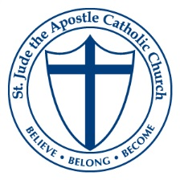

St. Jude the Apostle Catholic Church
Photo Release

St. Jude the Apostle Catholic Church has active promotional opportunities. Parishioners, including children, may appear in photographs, publications, films, interviews, web page, or videotapes made in conjunction with these and other church-related activities. These photographs or interviews may appear in printed materials, local or national media, and on the internet. By signing below, I grant permission for photo(s) of my child(ren) to be used as necessary to help promote and celebrate parish life at St. Jude.

________________________________ _______________
Print Name of Minor Date

________________________________ ___________________________________
Print Name of Parent or Guardian Signature of Parent or Guardian

