[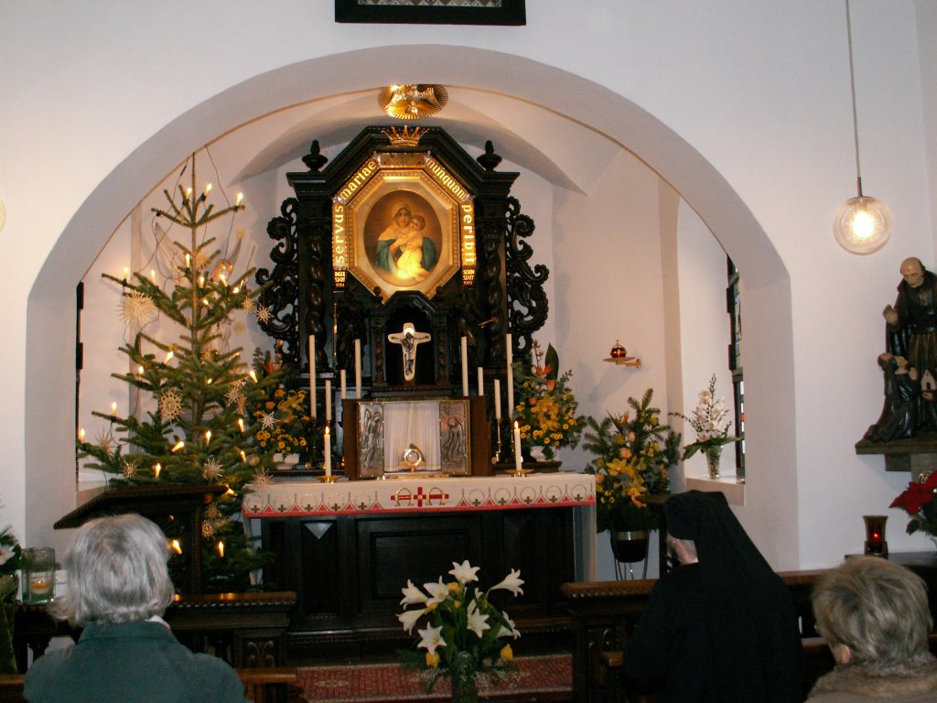](http://www.google.com/url?sa=i&rct=j&q=&esrc=s&source=images&cd=&cad=rja&uact=8&ved=0ahUKEwi8sazakYDZAhVE3FMKHQZ8DXQQjRwIBw&url=http://schoenstattblog.blogspot.com/2005/12/&psig=AOvVaw07-Teps_89vY1I5lYHKDzy&ust=1517416375058185)