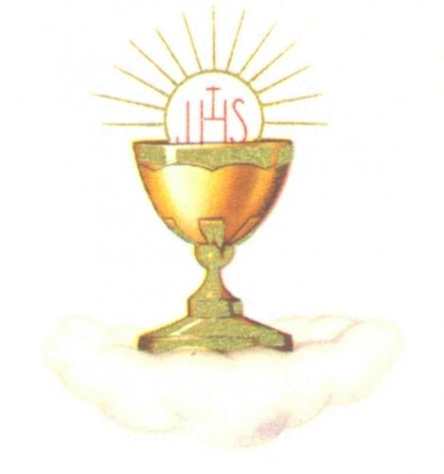
SAINT JUDE the APOSTLE CATHOLIC CHURCH

First Reconciliation & First Eucharist
Registration Form – 2019/2020

Candidate Information ~ Please Print Clearly Candidate Goes by: ___________________________

Candidate’s Formal Name: _________________________________________________________________
(first) (middle) (last)

Birth Date: ___________________________ Birth place (City/State) ________________________________

Place of First Grade Religious Education: ______________________________________________________

Please list any special medical/learning concerns for your child: ___________________________________________

_________________________________________________________________________________________________

PARENT CONTACT INFORMATION

Father’s Full Name ______________________________________________________________________________
(First) (Middle) (Last)

Mother’s Full (Maiden) Name ______________________________________________________________________
(First) (Middle) (MAIDEN)

Street Address:__________________________________________________________________________________

City: __________________________________________ State: ________________ Zip: ______________________

Telephone: ____________________________ Email: ___________________________________________________

PARISHIONER VALIDATION Circle One

Is the candidate a registered parishioner of St. Jude the Apostle Catholic Church? Yes No
Required for non-parishioners: A letter from your Pastor granting permission.

BAPTISM VALIDATION (Certificate copy must be included unless baptized here at St. Jude)

Was the candidate baptized in the Catholic Church? Yes No
(If not baptized in the Catholic Church, additional information is required. Contact the Coordinator for details.)

Church of Baptism: _______________________________________________________________________

Street Address: ___________________________________________________________________________
If Not St. Jude
City: _____________________________________ State: ___________ Zip: ____________

Date of Baptism: _____________________________________ Copy of certificate included? Yes No

“Eu sou o pão vivo, descido do céu. Quem comer deste pão viverá eternamente (...) quem come a minha Carne e bebe o meu Sangue tem a vida eterna (...) permanece em mim e eu nele” (Jo 6, 51-56).

